**Fuzzy Inference System for Covid-19**

**Vishal Kumar, MIT2019090**

COVID-19 is the infectious disease caused by the most recently discovered Corona virus. Corona virus is a pandemic declared by WHO. I have created an Inference system for covid-19, that will predict the chances of a person being infected with corona virus using given symptoms.

As the data given by WHO, most common symptoms are: Fever, Dry cough and Tiredness. Some patients may have breathing problem, aches and pains, nasal congestion, runny nose, sore throat or diarrhea.

There are two fuzzy inference systems:

1. **Mamdani:** Mamdani systems have more intuitive and easier to understand rule bases, they are well-suited to expert system applications where the rules are created from human expert knowledge, such as medical diagnostics.

* Intuitive
* Well-suited to human input
* More interpretable rule base
* Have widespread acceptance

1. **Sugeno:** Ituses singleton output membership functions that are either constant or a linear function of the input values. The defuzzification process for a Sugeno system is more computationally efficient compared to that of a Mamdani system, since it uses a weighted average or weighted sum of a few data points rather than compute a centroid of a two-dimensional area.

* Computationally efficient
* Work well with linear techniques, such as PID control
* Work well with optimization and adaptive techniques
* Guarantee output surface continuity
* Well-suited to mathematical analysis

**System Description:**

For my fuzzy system, I have taken most common symptoms as our input and the output will be the chances of being infected: High, Moderate and Low.

I have created the rules based on given inputs. Like, If a person has symptoms as High fever, High level of tiredness and Severe Cough then the person will be more likely to be a COVID-19 positive. There are total 12 rules that I have used for system design.

**Observations:**

**Mamdani:**

**Rules:**

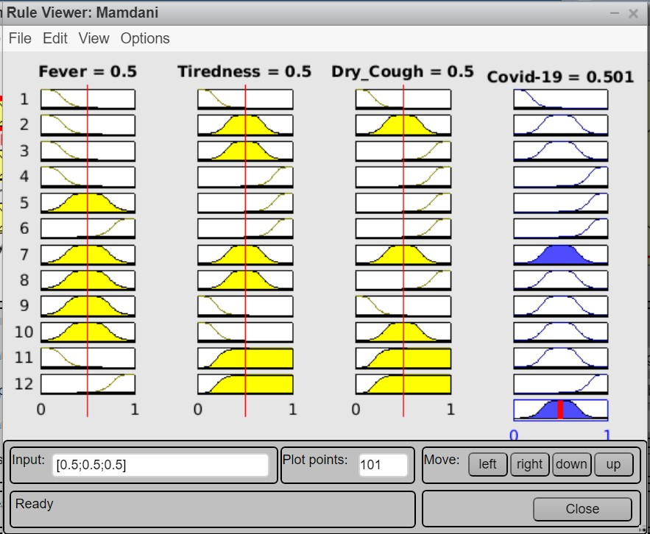

**Covid-19 vs Fever, Dry_Cough and Tiredness:**

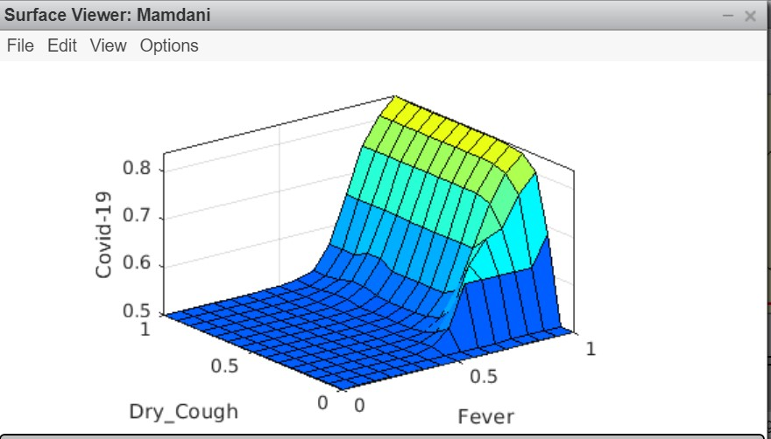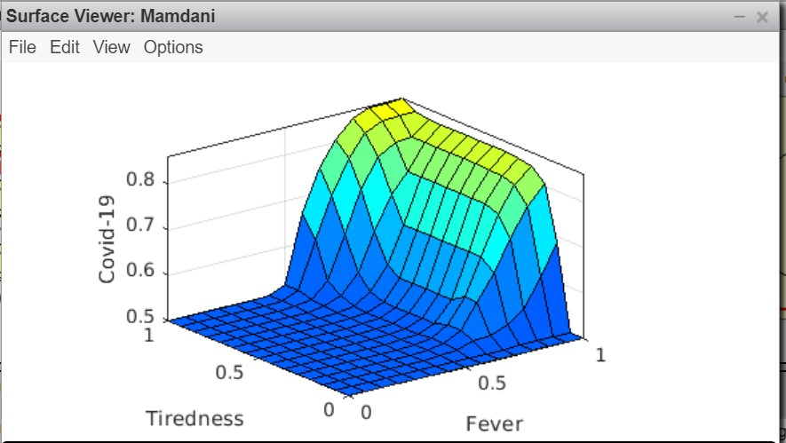

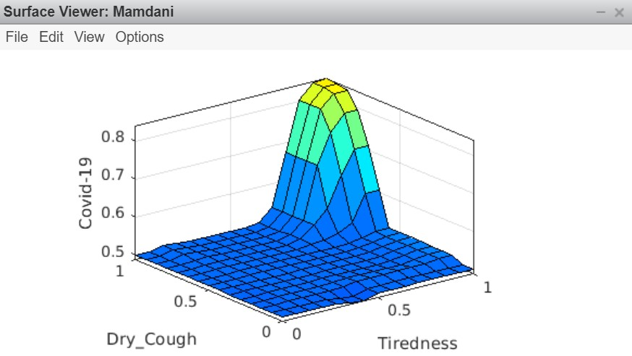

**Sugeno:**

**Rules:**

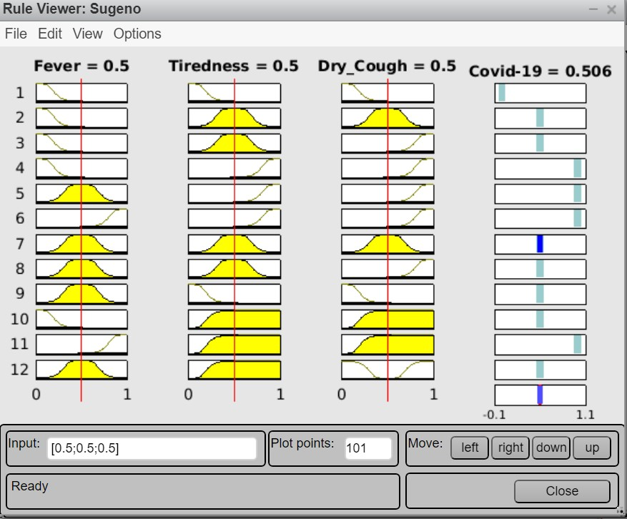

**Covid-19 vs Fever, Dry Cough and Tiredness:**

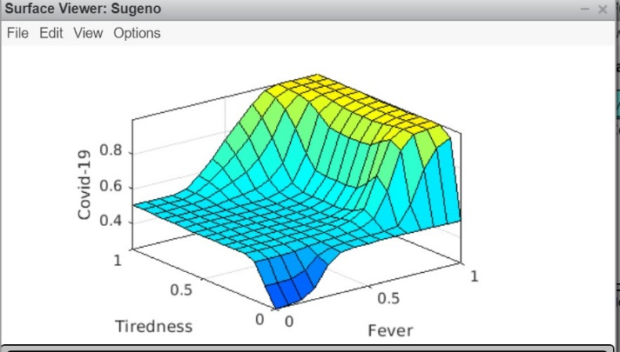 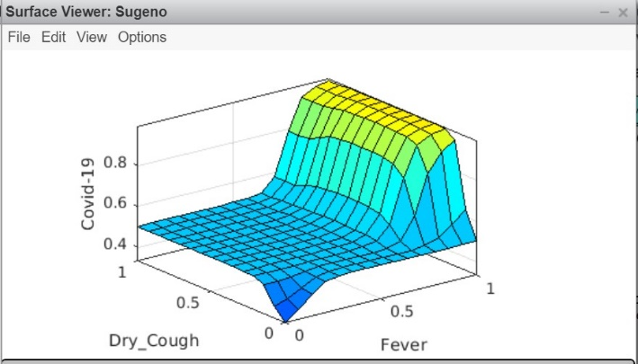

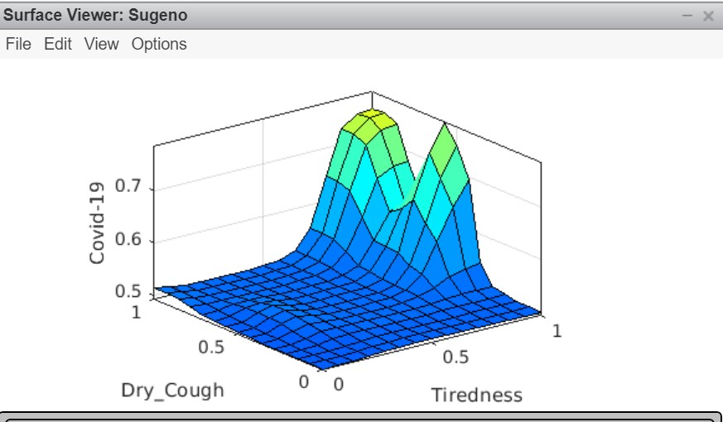

The results show that Sugeno model has outperformed Mamdani model in all of the measurements. This shows that Sugeno structure is more robust than Mamdani. Overall, the results show that Sugeno model is not affecting by the errors as much as the Mamdani model. This shows that Sugeno is better than Mamdani especially in dealing with problems that contain high degree of uncertainty. We can also observe that Sugeno model has better probability while setting the rules for COVID-19. But Mamdani is widely used because Mamdani FIS is more intuitive in terms of rule base.

The steep curve of Mamdani shows that it is taking centroid of the datasets but Sugeno curves has continuous curve which is why it is performing better than Mamdani. Sugeno uses the weighted sum of the dataset.